- Aberdeen District Motor Club (ADMC) in association with Kincardine Castle Estate are proud to present 2 National B status Hill Climb Meetings at Kincardine Castle, Kincardine O’Neil, Aberdeenshire. Postcode AB34 5AE; (57°05'22.5"N 2°39'32.1"W). The event dates are July 1st and 2nd 2023.

- All operational aspects of the race will be governed by the MSUK permits issued to ADMC. The MSUK licensed Clerk of the Course for the event will be Mr. Ian Shiells.

- All financial aspects of the event including but not limited to entry fees and official’s fees and expenses and equipment costs will be managed by and the responsibility of the Kincardine Estate (the promoters)

- The event will be governed by the general regulations of MOTORSPORT UK (incorporating the International Sporting Code of the FIA); these supplementary regulations; and any written instructions that Aberdeen District Motor Club (ADMC) (the organizer) or the assigned Clerk of the Course may issue for the event.

- MOTORSPORT UK permit has been approved – Permit Number 130639

- The event is open to members of any clubs that are MSUK registered members of the Scottish Association of Motor Sports Clubs or Association of Northern Car Clubs. Also open to members of Hillclimb and Sprinting Association (HSA) and of course Scottish Sprint and Hill Climb Championship (SSHC). Club membership cards will require to be shown at sign in.

- These meetings will be conducted on the West Drive of the Castle and are subject to the issuance of the inaugural MSUK track license. As such these meetings at Kincardine Castle are not currently included in any championships. It should be noted that assuming these meetings are successful they may be included in future British Hill Climb Championships (BHC). The organizer’s of the BHC have asked to be kept informed of our progress.

- All competitors must produce a valid driving license as well as Club Membership Card and a competition license to minimum MSUK Inter-Club level.

The program of the meeting will normally be as follows:

Scrutineering starts | 08:00 (There may well be opportunity to complete scrutineering the evening before the meeting)
Practice starts | 09.00
First Competition runs | 10.30, or 15 minutes after the last practice run  The timetable will be published in the final instructions.

- The track follows a right-hand turning course 650 meters in length, which rises through approximately 35 meters. The racing track has an asphalt surface.

- The paddock area is on entirely flat ground and is accessed and surrounded by well established and rolled hardcore. The access loop road back to paddock from the finish line also has an asphalt surface. The holding loop at the bottom of the west drive where cars are required to loop around before approaching the start line again in order to race was established in 2016 and consists of rolled hard core. It should be noted that tyre cleaning on the asphalt surface will be permitted and encouraged before arriving at the start line. It should be noted that the access track to the paddock was deemed potentially not suitable for single seater competition cars due to rolled hard core surface and arrival angles. This is reflected in the class lists available.

NB – Following the MSUK track inspection it has been stated that unfortunately we are unable to include single seater racing cars this year. Our MSUK track license will stipulate vehicles entries are restricted to production-based cars for the road.

- It is intended that batches of entrants will proceed down the track from the paddock area to beyond the start line, batch will enter the holding loop and then return on the lower drive to approach the start line again to race. There is adequate space for up to 40 cars in the holding loop. The organizers expect that no more than 20 cars will be sent down the track at any one time. This to avoid potential overheating etc.

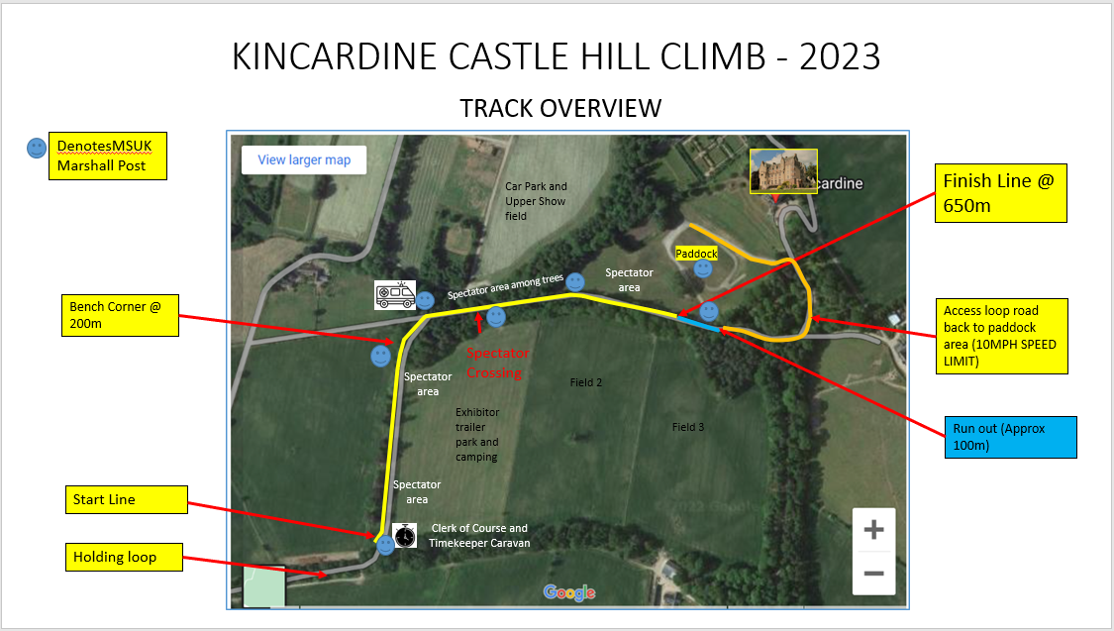

Please check the number of the class you are entering in Appendix I.

D) SHARED ENTRIES
Shared entries will be permitted and managed accordingly. Please mark clearly on entry, the first and second drivers.
Providing the vehicle is not shared two vehicles maybe entered by one driver. (But not in the same class)

The following class structure may be applied:
Division A Road Going Cars (Taxed and MOT – evidence reqd)
Fireproof coveralls recommended
A1 | Saloon Cars up to 1400cc
A2 | Saloon Cars over 1400cc and up to 2000cc
A3 | Saloon Cars over 2000cc
A4 | Sports Cars up to 1400cc
A5 | Sports Cars over 1400cc and up to 1700cc
A6 | Sports Cars over 1700cc
A8 | Marque Road Sports Cars
Division B Modified Cars
Fireproof coveralls mandatory
B1 | Modified Saloon Cars up to 1400cc
B2 | Modified Saloon Cars over 1400cc and up to 2000cc
B3 | Modified Saloon Cars over 2000cc
B4 | Modified Sports Cars up to 1400cc
B5 | Modified Sports Cars over 1400cc and up to 1700cc
B6 | Modified Sports Cars over 1700cc
Division C Competition Cars
Fireproof coveralls mandatory
C0 | Saloon Libre Cars
C1 | Sports Libre Cars up to 1400cc
C2 | Sports Libre Cars over 1400cc and up to 1800cc
C3 | Sports Libre Cars over 1800cc
Division D- Classic and Thoroughbred Cars (Period defined)
Fireproof coveralls mandatory
D1 | Classic and Thoroughbred Road Cars
D2 | Classic and Thoroughbred Modified Cars
Division E- Performance Demonstrations
Cars & drivers do require to sanctioned by the MSUK to do demonstration runs. Entrants will be vetted for approval before they are accepted.
Demo |  | Performance Demonstrations

IMPORTANT NOTES - classes

- All competitors and vehicles must comply with MOTORSPORT UK Common Regulations for Competitors and Specific Regulations for Hillclimb as set out in the current MOTORSPORT UK Yearbook Sections H to L and S and the relevant regulations of the Scottish Sprint, Hillclimb and Speed Championships. All vehicles must comply with the MOTORSPORT UK Technical Regulations.
- Entrants in Division A Road Cars should note the scrutineers’ requirement to carry a paper copy of the relevant MOT certificate and Emissions Test result and insurance certificate.
- Cars may use Methanol or Bio fuel subject to the car complying with the appropriate MOTORSPORT UK regulations and the appropriate Championships allowing the use of that specific fuel. All cars using Methanol must display an orange disc adjacent to their competition numbers and use an additive to specifically enhance the smell and visual impact of burning.
- No hybrid or electric cars are permitted within the timed race.
- Class definitions are in terms of the Scottish Hillclimb Championship Technical Regulations,
- Classes in Division D will be run on a target time basis. If five or more cars of one make enter, a separate class may be added at the discretion of the Secretary.
- Entries for post 1980 cars may be accepted in Division D as long as they are identical to a model that was in existence prior to that date.
- Only period modifications are permitted in Division D with the exception of tyres, where allowances will be made for older cars when the available options are limited due to the size and type of tyre required.

- There will be awards for Divisional Winners in each of Road Car, Modified Car, Competition Car, Standard Car and Classic (MOTORSPORT UK period defined) Car. These winners will not be eligible for Class awards. There will also be awards for each class and a second place awarded subject to a minimum of five cars entered in that class.

- The entry list will open on or shortly after 7th March following MSUK track inspection. The closing dates for entries are midnight June 2nd 2023.

- Online entry and payment will be available on the Kincardine Castle website via Rallyscore system at https://www.rallyscore.net/#/ where finalized Supplementary Regulations will also be published. The entry fee is £150 for the weekend or £90 per day.

- If the entrant is under 18, or the entrant is not the driver, please contact the entry secretary initially via events@kincardineestate.com

- No postal entries are accepted. If for any reason an on-line entry cannot be made, please contact the entry secretary @ events@kincardineestate.com

- Entries will be acknowledged by email and the entry list and final instructions will be available on the Rallyscore system after the closing date. If an event is cancelled, entry fees will be returned to entrants less £5 administration fee. A refund in full will be made to any entrant who withdraws before the closing date of the meeting, after which £5 will be deducted for administration. Any entrant failing to notify the Secretary of the Meeting of non-appearance will NOT be entitled to any refund.

- The maximum entry for the meeting is 80. The minimum is 40. The minimum for each class is 3. Should any of these minimum figures not be reached, the organizers reserve the right to cancel the meeting, or to amalgamate classes as they judge appropriate.

The officials of the meeting will be as follows and confirmed in Final Instructions

Clerk of the Course | Ian Shiels
Secretary of the Meeting | TBA
MOTORSPORT UK Steward | TBA
Club Stewards | Alison Mitchell
Chief Scrutineer | Ken Wallace / Robin Wallace
Chief Timekeeper | Stan Thorogood
Noise Test Official | Irene Wallace
Paramedic | Euan Littlejohn

- Results will be posted online and sent via email to all competitors. A link to the online results system (by Raymond Mann) will be issued in the final instructions. Queries should be submitted electronically, by telephone, text message or video call.

- Any protests must be lodged in accordance with the provisions of the current MOTORSPORT UK year book. (Within 30 minutes of end of event)

- The starting order will be determined by class order. The paddock is at the top of the hill adjacent to the finish. Cars will be called to the paddock exit in batches. Cars will proceed down the track in batches to the holding loop where they will turn and once again approach the start line. Cars will start singly. A green light indicates that cars may start in their own time, and a white line and banner indicate the finish. The method of timing is electronic and Competitors are reminded that a timing strut in accordance with MSUK year book regulation S.9.1.6 is required

- There will be a minimum of one practice run, hopefully followed by four or five timed runs. All competitors will have opportunity and must walk the course before 0900 on the day of the event.

- Competitors will be identified by numbers that should be displayed according to the current MOTORSPORT UK Regulations. Numbers will be available for purchase at signing-on.

- The entry to the start area is defined by the Pre-Start Line. Once this has been passed a car will be deemed to be under starter’s orders. Mechanics may only accompany cars as far as the Pre-Start Line and may not enter the area without the express permission of the Marshal.

- A number of bollards indicate the track limits in a number of places. A 5 second penalty (no warnings) will be issued to any car which touches a bollard and dislodges it from its base (S9.5.4). All Marshals will become Judges of Fact for Track Limits, their names listed accordingly and displayed on the event noticeboard prior to the start of all runs. A written report form is held by the Clerk of Course for recording infringements (S9.5.8)

- All drivers must be signed on and report to the Clerk of the Course for a briefing before the start of the event as advised. It is anticipated that this meeting will be conducted at 8.45 am each day. Any driver not attending the briefing will be eliminated from the event.

- It should be noted that all competitors will require to be on site and established in the paddock area by 8am as the competitors entry route crosses the track. Failure to do so may (will probably) result in exclusion from the event. Access gate will close, and final track cleaning will commence just after 8am. Entry to the site will be permitted during the previous afternoon and evening. (Between 12noon and 9pm). Sunday competitors will only be able to access on Saturday evening or early Sunday.

- For various reasons including public attendance and so that competitors can achieve as many runs as possible a tight timetable will be operated before and during the event. Just like in Formula 1 if you are not ready for your pre allocated time slot you will miss the start / run and the show will go on.

- Drivers must at all time follow the verbal instructions of Marshals

- Competitors whose run is interrupted by a RED FLAG will only be allowed a rerun at the discretion of the Clerk of the Course. When shown a red flag, the competitor must bring his/her vehicle safely to a stop and await verbal instructions from a marshal.

- A strict site speed limit of 10 mph will be applied to all roads and access tracks at all times (except when competing on the track). When descending the track to the lower holding loop and assuming the track crossing is closed a speed limit of 20 mph is permitted on the track. Any driver failing to adhere to these limits will be disqualified and may be prohibited from further participation.

- At all times when on the track in a moving vehicle drivers will be fully secured and wearing all required PPE etc. properly. (Helmets gloves etc.)

- Please note that animals are not permitted at the event throughout the weekend.

- Competitors are advised that a 110 dB noise limit, measured at 0.5 m distance, will be enforced for Racing and Sports Libre Cars and a noise limit of 108dB will be enforced for all other Classes. Cars exceeding the specified noise limits may be admitted at the discretion of the Clerk of Course. The noise will be tested in the area specified on the Track License. All cars must be fitted with a Rev Counter to allow this test to be performed.

- Out with the timed competition we are permitted to conduct performance demonstrations on the track throughout the day. Cars and drivers will require to sanctioned by the Motorsport UK to do Demonstration runs. Entrants will be vetted for approval before they are accepted. Please do enter Demo class in Rallyscore system and competition secretary will process accordingly with MSUK in due course.

